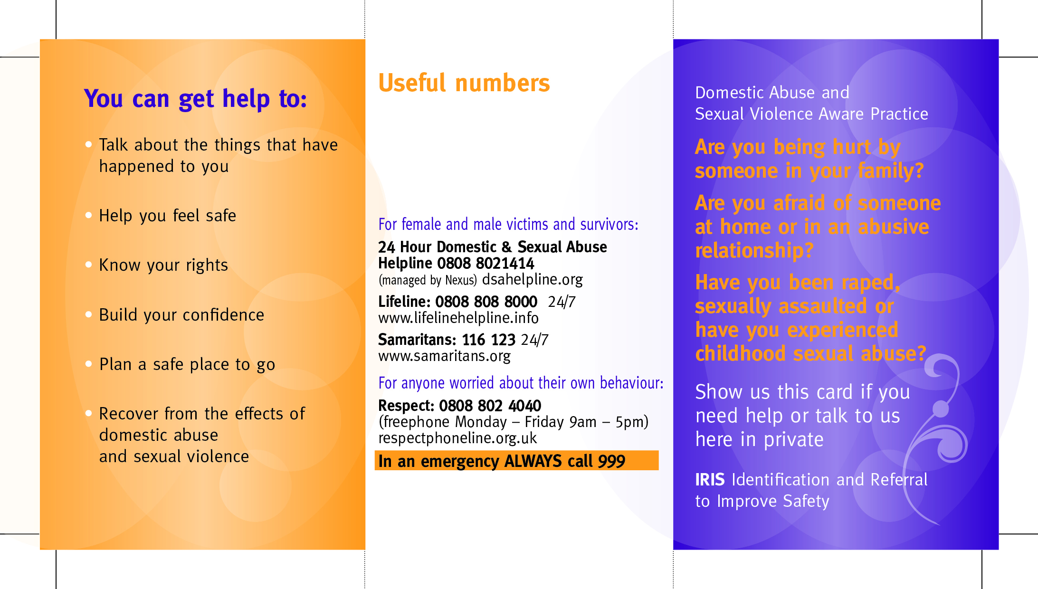
Speak to your GP or a member of the GP practice staff or call;
IRIS Worker: Kimberley
028 9066 6049
07707290442

